以下为测试sql脚本数据:

drop table if exists PaymentInfo;

/*==============================================================*/

/* Table: PaymentInfo */

/*==============================================================*/

create table PaymentInfo

(

Id int not null auto_increment,

TransNo varchar(32) not null,

Status int not null,

CreatTime varchar(8) not null,

Extend varchar(32),

primary key (Id)

);

drop table if exists RefundInfo;

/*==============================================================*/

/* Table: RefundInfo */

/*==============================================================*/

create table RefundInfo

(

Id int not null auto_increment,

TransNo varchar(32) not null,

Status int not null,

CreatTime varchar(8) not null,

Extend varchar(32),

primary key (Id)

);

----订单表数据

insert into PaymentInfo (TransNo,Status,CreatTime,Extend) values ( "T000001", 0, "20190323","72334");

insert into PaymentInfo (TransNo,Status,CreatTime,Extend) values ( "T000002", 0, "20190323","72334");

insert into PaymentInfo (TransNo,Status,CreatTime,Extend) values ( "T000003", 0, "20190323","72334");

insert into PaymentInfo (TransNo,Status,CreatTime,Extend) values ( "T000004", 0, "20190323","72334");

insert into PaymentInfo (TransNo,Status,CreatTime,Extend) values ( "T000005", 0, "20190323","72334");

insert into PaymentInfo (TransNo,Status,CreatTime,Extend) values ( "T000006", 0, "20190323","72334");

---退款表数据

insert into RefundInfo(TransNo,Status,CreatTime,Extend) values ( "T000001", 0, "20190323","72334");

insert into RefundInfo(TransNo,Status,CreatTime,Extend) values ( "T000001", 1, "20190323","72334");

insert into RefundInfo(TransNo,Status,CreatTime,Extend) values ( "T000001", 2, "20190323","72334");

insert into RefundInfo(TransNo,Status,CreatTime,Extend) values ( "T000001", 3, "20190323","72334");

insert into RefundInfo(TransNo,Status,CreatTime,Extend) values ( "T000002", 0, "20190323","72334");

insert into RefundInfo(TransNo,Status,CreatTime,Extend) values ( "T000006", 3, "20190323","72334");

inner join on

等值连接，只返回两个表中联结字段相等的行(若两者匹配的行数不一致，则不返回;若一致并且多条，会)。

eg：

---等值连接

select * from PaymentInfo p inner join RefundInfo r on p.TransNo = r.TransNo

--查询结果

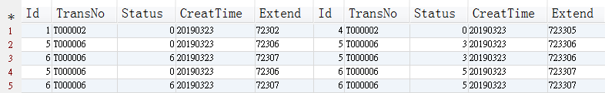

left join on

左联接， 返回包括左表中的所有记录和右表中联结字段相等的记录(只返回那些左表有值，并且左表右表数据为一对一，多对一，或多对多(此时左表右表中条件行数一致的记录))；

eg：

---左联接

select * from PaymentInfo p left join RefundInfo r on p.TransNo = r.TransNo

--查询结果

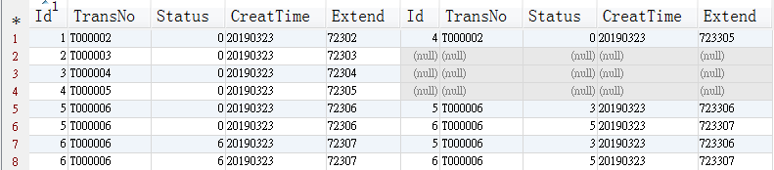

right join on

右联接， 返回包括右表中的所有记录和左表中联结字段相等的记录，规则和左连接一致；

---右联接

select * from PaymentInfo p right join RefundInfo r on p.TransNo = r.TransNo

--查询结果

